**Acceptance of Service Proposal Clinic Registration of Directorate of Research and Community Service (DRPM)**

By: **Chalid Luneto**. April 17, 2021. 10:47:04

In order to improve the quality and competence of the lecturer service proposals at the national level, the Research and Community Service Office (LPPM) will hold a Service Proposal Clinic funding of 2022.

To Mr. and Mrs. Lecturers at the Universitas Negeri Gorontalo, who are interested to participate in this activity can register by submitting a draft proposal to LPPM UNG until May 7, 2021.

Conditions for proposal acceptance:

* Proposal writing refers to the Research and Community Service Guidelines of the XIII edition.
* Proposal is submitted to the LPPM in 2 copies (bookbinding)
* Softcopy is sent to email [lpm@ung.ac.id](mailto:lpm@ung.ac.id)

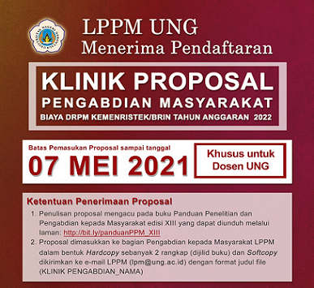

LPPM UNG

Accepting Registration

Proposal Clinic

Community Service

Directorate of Research and Community Service Funds of the Ministry of Research and Technology/National Research and Innovation Agency for the fiscal year of 2022

Proposal Submission Limit until May 07, 2021. Devoted for UNG Lecturers

Conditions for Proposal Acceptance

1. Proposal writing refers to the Research and Community Service Guidelines of the XIII edition and can be downloaded from the link: <http://bit.ly/panduanPPM_XIII>

2. Proposal is submitted to the community service unit of the LPPM as hardcopy in 2 copies (bookbinding) and the softcopy is sent to LPPM e-mail ([lpm@ung.ac.id](mailto:lpm@ung.ac.id)) with file name format (KLINIK PENGABDIAN_NAMA)